SAM- Final Program

Final Circuit:

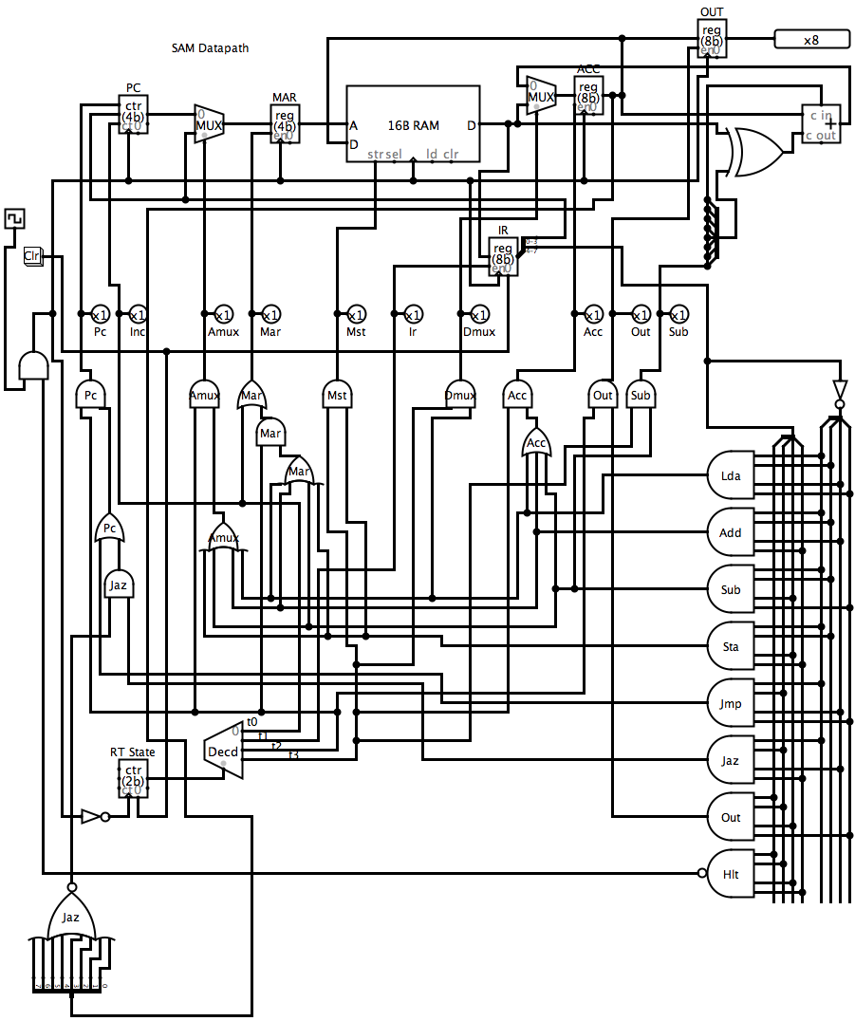

Final Program

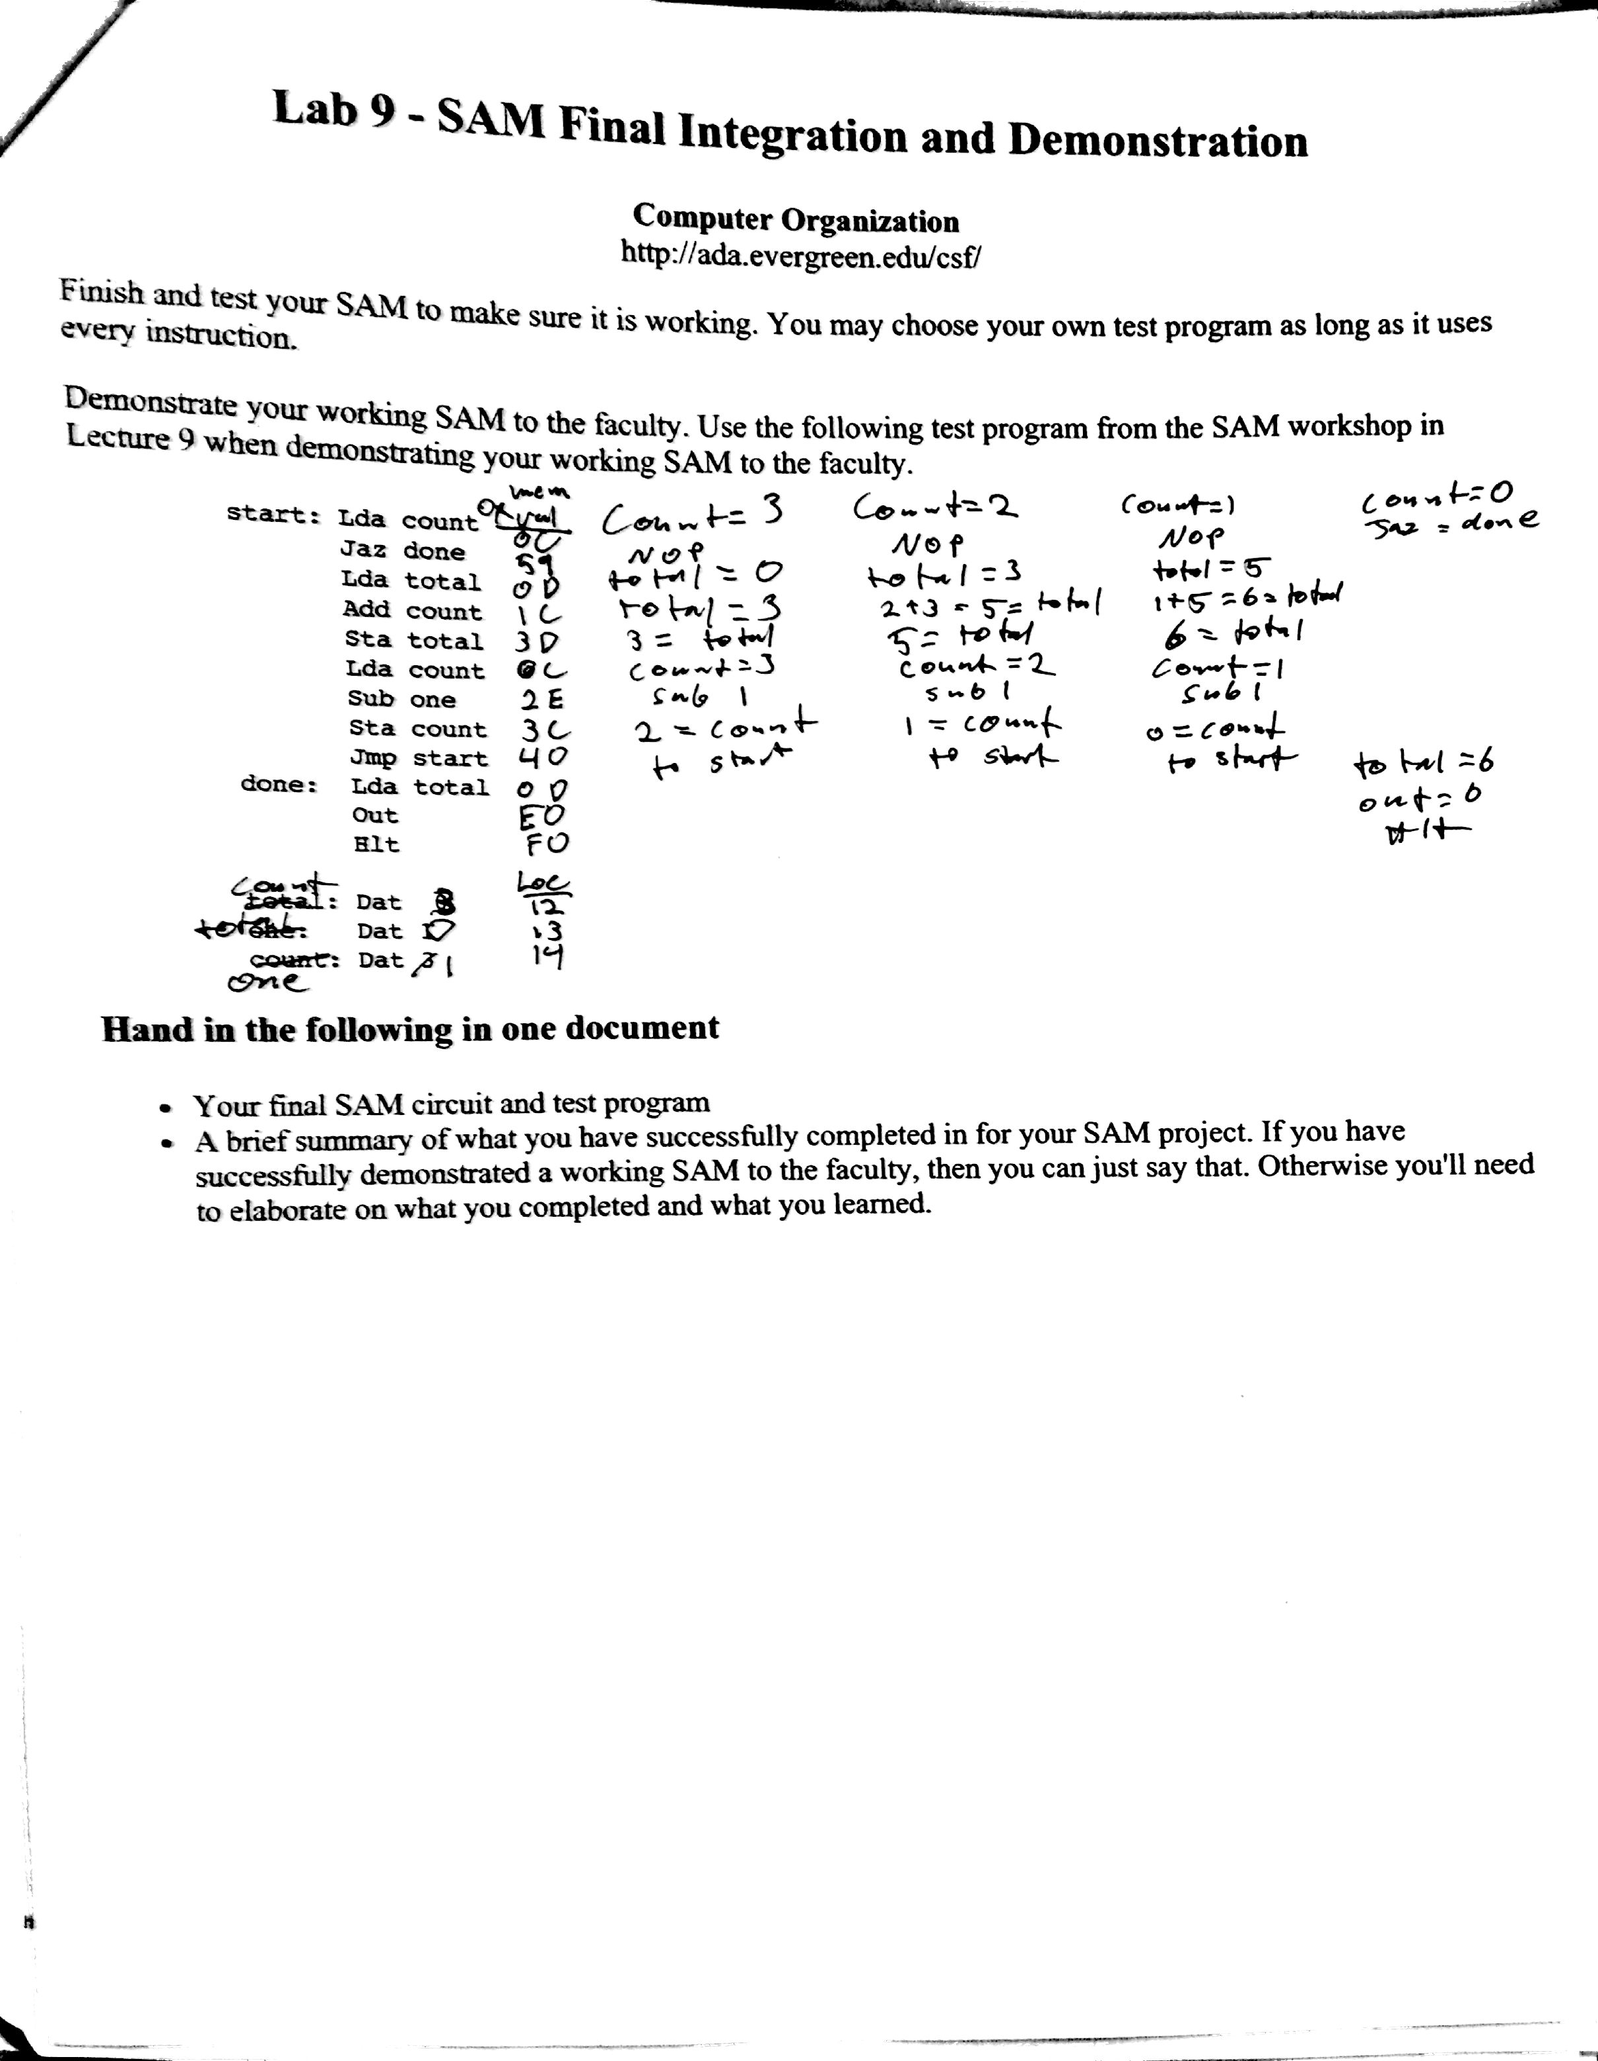Final output: 6

I demonstrated my SAM circuit to Rik who approved of it’s output and function. He then told Neal that I had completed the lab.